The applicant for a new public drinking water system must submit two standard forms: (1) Project Notification Form (PNF); and (2) Supplemental Form for New Public Drinking Water System. Additional information is available on Division of Drinking Water (DDW) website (drinkingwater.utah.gov). This supplemental form requests information related to typical issues that a new public drinking water system will face. Note that some of the information requested may not apply to your system.

Public Drinking Water System Name

1. Proposed Public Water System (PWS) Applicant Information:

Name:
Address:
City: |  |  |  |  |  |  | Zip Code:
E-Mail:
Business Phone:
Cell Phone:
Administrative Contact ☐ Owner ☐ PWS Manager ☐ PWS Operator ☐
Other: |  | (check all that apply)

Has the applicant read, and is the applicant familiar with, new PWS obligations pursuant to State of Utah Administrative Rules for Public Water Systems, specifically, Rule R309-105, Administration: General Responsibility of Public Water Systems?
Yes ☐ No ☐
Applicant Signature |  | Date

2. Service Connection Type
Projected number of service connections at full build-out:
Current number of service connections served by the proposed PWS: (Please list number next to the type of service connection. If needed, add detailed description below.)

Residential |  | Commercial |  | Industrial
Agricultural |  | Combined
Description:

Population Served by the Proposed PWS
Projected population served by the proposed PWS at full build-out: ______________
Current population served by the proposed PWS (please list the number of people served next to the appropriate use):
Residential (year-round):
Residential (between 6 months to 12 months each year):
Residential (less than 6 months per year):
Residential (less than 6 months per year):
Non-residential use (year-round):
Non-residential use (between 6 months to 12 months each year):
Non-residential use (less than 6 months per year):

Location
County: |  |  | City/Town:
Address or description:

Operation Period
Is the proposed water service year-round? Yes ☐ No ☐
If the water service is not year-round, identify the period of the proposed seasonal water
service: from |  | to

3. Category of the proposed PWS (check only one):
☐ Community water system (CWS)
☐ Nontransient noncommunity water system (NTNC)
☐ Transient noncommunity water system (TNC)
[Guidance: Contact Patti Fauver at pfauver@utah.gov or (801)536-4196 for questions related to determining public water system category. See Division of Drinking Water Rule R309-100-4(2).]

Drinking Water Source
4. Does the proposed PWS have its own source of water that is already-existing? Yes☐ No☐
If yes, identify the existing source name, provide the location (lat-long NAD83 preferred),
and describe the source:
Have any water quality analyses been made of the source water? Yes ☐ No ☐ N/A ☐
If yes, please attach a copy of the water quality analyses with this form.

[Guidance: The existing water source of a proposed PWS will be required to undergo DDW’s plan review process to determine whether it meets the public drinking water standards. Such standards include construction standards, drinking water quality standards, source protection plan, certified well grout to a depth of 100 feet, etc. If an existing water source does not meet the public drinking water standards, the proposed PWS will be required to develop or acquire an alternate public drinking water source that meets public drinking water standards.]
5. Will the proposed PWS receive drinking water from an existing PWS? Yes ☐ No ☐
If yes, identify the existing PWS name and water system number:

If the proposed PWS will receive drinking water from an existing PWS, will the proposed PWS also develop its own source of water to supplement water delivered from another PWS?
Yes ☐ No ☐ N/A ☐
[Guidance: DDW encourages new water service areas to obtain drinking water through already-existing public water systems. Regulatory controls on water systems are extensive, and creation of a new water system is less preferable than annexing to an existing public water system. Identify any Utah public water system or wholesale connection that could provide drinking water to the proposed water service area in lieu of creating a new PWS.]
6. Will the proposed water system develop its own water source(s)? Yes☐ No☐
If yes: Proposed new well source? Yes☐ No☐
Proposed new spring source? Yes☐ No☐
Proposed new surface water source? Yes☐ No☐
Proposed new water treatment plant? Yes☐ No☐
Describe the possible new source(s):

[Guidance: No new public water system can be approved by DDW without a drinking water source. The common options for a new water source are wholesale connection, wells, springs, and surface water treated in accordance with Federal and State Rules. Surface water treatment facilities are generally expensive to construct and operate. Identify here the well, spring, or surface water body, which may serve as the proposed new water system's water source.]

Engineering Review

7. A new water system will be required to provide detailed information, i.e., engineering plans and specifications prepared by a professional engineer licensed to practice in Utah, of existing and proposed drinking water facilities, including source, storage, pump, distribution system, etc., for review. This review is to ensure compliance with the design and construction standards of public drinking water systems and to determine whether an approval to construct and an operating permit can be issued for the new water system. A new water system will be rated as an approved water system after it obtains an operating permit from the Division of Drinking Water.

Do you have a licensed engineer who will prepare the plans and specifications of this new PWS for submittal? Yes ☐ No ☐

If yes, identify the name and contact information of the licensed engineer:
Name:
Company:
Telephone:
E-Mail:

[Guidance: Contact the engineering staff at (801)536-4200 for information related to drinking water facility construction standards and plan review requirements. See Division of Drinking Water Rules R309-500 through 550.]

Capacity Development Plan (or Business Plan)

8. Regarding the capacity development plan requirement for the proposed PWS per Division of Drinking Water Rule R309-800, Capacity Development Program (check only one):
☐ Community water system (CWS): Capacity Development Plan will be required.
☐ Nontransient noncommunity water system (NTNC): Capacity Development Plan will be required.
☐ Transient noncommunity water system (TNC): Capacity Development Plan is not required.

[Guidance: Contact Nagendra Dev at ndev@utah.gov or (801)536-0098 for information related to capacity development assessment. See Division of Drinking Water Rule R309-800.]

Source Protection

9. A Preliminary Evaluation Report (PER) is required for a new drinking water source, or for a source that has not previously been reviewed and approved by the Division.

A licensed geologist (PG) or engineer (PE) must prepare the Delineation Report section of the PER for a groundwater source. If you plan to use a well or spring, do you have a PG or PE who will prepare the Delineation Report for the source(s)? Yes ☐ No ☐
If yes, identify the name and contact information of the licensed geologist or engineer:
Name:
Company:
Telephone:
E-Mail:

[Guidance: Contact the source protection staff at (801)536-4200 for information related to source protection requirements. See Division of Drinking Water Rules R309-600 and R309-605.]

Certified Operator

10. All Community and Non-transient Non-Community drinking water systems (CWS and NTNC) must obtain a certified operator that has Distribution certification to the level of the water system's population. Any water system that treats surface water or water under the direct influence of surface water must have a Treatment operator certified at the grade of the water system depending on the population served by the water system.
Will this new PWS be required to have a certified water operator? Yes ☐ No ☐
If you have made an arrangement with a certified operator, identify the name and contact information of the water operator:
Name:
Company:
Telephone:
E-Mail:

[Guidance: Contact Kim Dyches at kdyches@utah.gov or (801)536-4202 for information related to water operator certification. See Division of Drinking Water Rule R309-300.]

Drinking Water Monitoring and Reporting

11. All drinking water systems are required to comply with the water quality monitoring and reporting requirements of drinking water system sources and distribution system. The samples required depend upon many factors, such as; the type of water system, the type of source water, the type of treatment provided and the population served among others. Upon Division review of the information provided a system specific monitoring schedule will be established and provided to the water system management.

[Guidance: Contact Patti Fauver at pfauver@utah.gov or (801)536-4196 for information related to monitoring, reporting, and compliance requirements. See Division of Drinking Water Rules R309-200 through 225.]

Water Rights

12. In which Division of Water Rights Region is the proposed PWS's service area (see Attachment 1)?
☐ Northern Regional Office (Logan)
☐ Weber River/Western Regional Office (SLC)
☐ Utah Lake/Jordan River Regional Office (SLC)
☐ Eastern Regional Office (Vernal)
☐ Southeastern Regional Office (Price)
☐ Sevier River/Southern Regional Office (Richfield)
☐ Southwestern Regional Office (Cedar City)

[Guidance: DDW may wish to consult with the State Engineer about water rights issues for the proposed public water system. Identify in #12 and #13 the Division of Water Rights Region in which the proposed PWS is located, and any Division of Water Rights personnel with whom representatives of the proposed PWS had communicated.]

13. Identify the State Engineer's Office representative you have contacted (see Attachment 1):
Name:
Telephone:
E-Mail:

14. With respect to water rights "already in hand" for the proposed PWS:

a. Water rights number(s):
b. Nature of use (e.g., municipal, domestic, irrigation, etc.):
c. Acre-feet, cubic feet per second (CFS), other:
d. Do the Division of Water Rights’ records show the ownership of water rights is in the
name of the PWS? Yes ☐ No ☐ (Explain)
e. Change application filed? Yes☐ No☐ N/A☐ [Note that change applications may take up to 6 months for the associated advertising and protest processes.]
f. Point of diversion (POD) change filed? Yes☐ No☐ N/A☐
g. Nature of use change filed? Yes☐ No☐ N/A☐
[Guidance: DDW Rules require that a public drinking water system must have a valid right to use the water for its water sources. Namely, the water rights must be classified by the State Engineer as domestic or municipal drinking water rights. The State Engineer may not necessarily change agricultural, irrigation, mining, or stock-watering water rights to domestic or municipal drinking water rights. Identify the water right number, types, and quantities that the proposed new public water system currently owns or controls.]

15. With respect to water rights intended to be acquired for the proposed PWS:

- Have you identified prospective water rights sellers (e.g., private party, etc.)?
Yes☐ No☐ N/A☐
If yes, describe the prospective seller:

[Guidance: If the proposed PWS will purchase as-yet un-acquired water rights, identify the prospective seller of these water rights.]

b. Is any water rights acquisition contract appropriately contingent upon the State Engineer's change application approval? Yes☐ No☐ N/A☐
[Guidance: The State Engineer will not pre-judge change applications, and acquisition contracts should always allow for cancellation by the buyer in the event of change application denial by the State Engineer.]

16. With respect to water rights that would be provided by another entity for the proposed PWS:

- Have you contacted or entered into an agreement with an entity to provide drinking water under their water rights? Yes☐ No☐ N/A☐
If yes, identify the prospective water rights provider here (e.g., water conservancy
district, etc.):

[Guidance: If the proposed public water system will receive the water supply from an entity that holds the corresponding water rights, identify the prospective providers of these water rights.]

Public Service Commission

17. Have you contacted the Division of Public Utilities (DPU) to register the proposed drinking
water system? Yes ☐ No ☐ N/A ☐ (Explain)

If yes, identify the utility analyst at DPU who has been contacted with respect to the proposed new PWS:
Name:
Telephone:
E-Mail:

[Guidance: All public drinking water systems that sell water or charges water users must apply and be approved for either a Certificate of Convenience and Necessity (CPCN) or an Exemption. These forms can be found on the website of the Division of Public Utilities (DPU): http://publicutilities.utah.gov/forms.html. Identify in #17 and #18 any DPU staff consulted and their preliminary assessment of whether the proposed new water system will be exempt or regulated by DPU. If needed, contact DPU at (801)530-7622.]

18. Preliminary indication from DPU of the new PWS's regulatory status:
☐ Letter of Exemption ─ Nonprofit/mutual PWS serving members only;
☐ Certificate of Convenience & Necessity ─ For-profit PWS serving public;
☐ Not Applicable or other (Explain)

Fire Authority
19. Is this water system required to supply water for fire suppression? Yes ☐ No☐
Identify the local fire authority you have contacted with respect to fire suppression requirements:
Fire District:
Name:
Telephone:
E-Mail:
Required fire flow (in gallons per minute):
Required fire flow duration (in minute):

[Guidance: If the proposed water system will have fire hydrants in its distribution system or is required to supply water for fire suppression, the water system must be designed to meet the storage volume, flow and pressure requirements for fire flow.]

Miscellaneous

20. Will the proposed water system construction involve storm water or wastewater discharges, or septic systems? Yes ☐ No☐
[Guidance: A proposed water system or new development may need to obtain permits or approvals from the Utah Division of Water Quality, local Health Department, or local government such as city or county. If the proposed water system project involves storm water discharge during construction, wastewater discharge or septic systems, please contact the Utah Division of Water Quality at (801)536-4300 and the local Health Department.]

Additional Information

Northern Regional Office (LOGAN)
Will Atkin, Regional Engineer
1780 North Research Parkway, Suite 104
North Logan, UT 84341
Phone: (435) 752-8755
Fax: (435) 752-0062
Email: willatkin@utah.gov

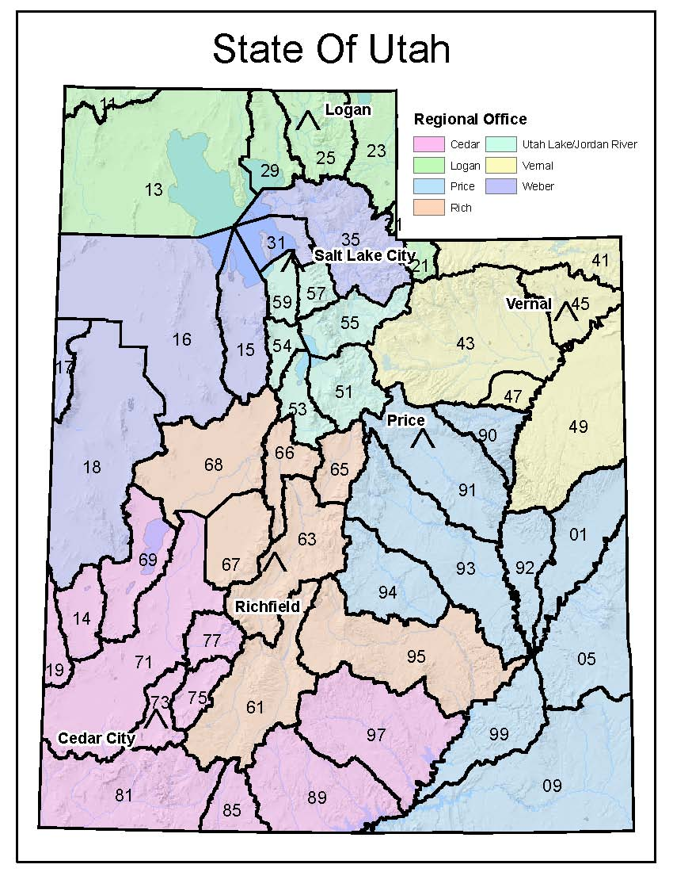
Weber River/Western Regional Office (SLC)
Ross Hansen, Regional Engineer
1594 West North Temple, Suite 220
P.O. Box 146300
SLC, Utah 84114-6300
Phone: (801) 538-7240
Fax: (801) 538-7467
Email: rosshansen@utah.gov

Utah Lake/Jordan River Regional Office (SLC)
Teresa Wilhelmsen, Regional Engineer
1594 West North Temple, Suite 220
P.O. Box 146300 SLC, Utah 84114-6300
Phone: (801) 538-7240
Fax: (801) 538-7467
Email: teresawilhelmsen@utah.gov

Eastern Regional Office (VERNAL)
Bob Leake, Regional Engineer
State and County Building
152 East 100 North
Vernal, Utah 84078-2126
Phone: (435) 781-5327
Fax: (435) 789-8343
Email: bobleake@utah.gov

Southeastern Regional Office (PRICE)
Marc Stilson, Regional Engineer
319 North Carbonville Road
P.O. Box 718
Price, Utah 84501
Phone: (435) 613-3750
Fax: (435) 613-3755
Email: marcstilson@utah.gov

Sevier River/Southern Regional Office (RICHFIELD)
Kirk Forbush, Regional Engineer
130 North Main Street
P.O. Box 664
Richfield, Utah 84701-0563
Phone: (435) 896-4429
Fax: (435) 893-8114
Email: kirkforbush@utah.gov

Southwestern Regional Office (CEDAR CITY)
Kurt Vest, Regional Engineer
585 North Main Street
P.O. Box 506
Cedar City, Utah 84721-0506
Phone: (435) 586-4231
Fax: (435) 586-2789

Familiarize with R309-105, Administration: General Responsibility of Public Water Systems
Contact Local Fire Authority

Submit to DDW: (1) Project Notification Form &
(2) Supplement Form for New Public Water Systems
Schedule DDW Inspection(s) during Construction
(Keep DDW apprised of construction as it progresses.)

Obtain Plan Approval from DDW for Drinking Water Sources and Facilities &
Commence Construction

Submit Record Drawings, Water Quality Data, etc. &
Obtain Operating Permit from DDW
Place New Drinking Water Sources and Facilities in Service &
Continue to Comply with Monitoring/Sampling/Operator Certification/Other Requirements

Identify Drinking Water Source (New vs. Existing Public Water Supply) &
Submit New Source Preliminary Evaluation Report (PER) if needed

Submit to DDW Preconstruction Engineering Plans
(R309-500-6(2), Pre-Construction Requirements, Licensed Engineer Stamped Drawings and Specifications)

Contact Division of
Public Utilities
Contact Division
Of Water Rights

Prepare Business Plan (Facilities Plan, Management Plan, Financial Plan)
(R309-800-5. Requirements for New Community & New Non-transient, Non-Community Water Systems)

